|  |
| --- |
| > setwd("C:/temp")  > library(foreign)  > my.data <- read.spss("UniWd-ED91data-Vote97.sav", to.data.frame = T)  re-encoding from CP1252  > names(my.data)  [1] "ed91" "Easting" "Northing" "area"  [5] "allppl" "VoteIndex" "wht_oth_pc" "ipb_pc"  [9] "non_home_own_pc" "no_car_pc" "overcr_pc" "loneparent_pc"  [13] "unemp_pc" "single_pens_pc" "single_pers_pc" "ft_pc"  [17] "stud_pc" "hh_llti_pc" "Multi_stress" "multistress" |
|  |
| |  | | --- | | > | |
| > library(GISTools)  Loading required package: maptools  Loading required package: sp  Checking rgeos availability: TRUE  Loading required package: RColorBrewer  Loading required package: MASS  Loading required package: rgeos  rgeos version: 0.3-26, (SVN revision 560)  GEOS runtime version: 3.6.1-CAPI-1.10.1 r0  Linking to sp version: 1.2-5  Polygon checking: TRUE  Warning message:  package ‘GISTools’ was built under R version 3.4.4  > my.shp <- readShapePoly("uni91edspolygons.shp")  Warning message:  use rgdal::readOGR or sf::st_read  > summary(my.shp)  Object of class SpatialPolygonsDataFrame  Coordinates:  min max  x 413737 416739  y 431602 434639  Is projected: NA  proj4string : [NA]  Data attributes:  AREA PERIMETER ED91  Min. : 6611 Min. : 403.8 08CXGD01: 1  1st Qu.: 26590 1st Qu.: 810.6 08CXGD02: 1  Median : 42490 Median :1065.2 08CXGD03: 1  Mean : 91492 Mean :1361.8 08CXGD04: 1  3rd Qu.: 85932 3rd Qu.:1508.1 08CXGD05: 1  Max. :629794 Max. :4512.7 08CXGD06: 1  (Other) :44  > plot(my.shp) |
|  |
| |  | | --- | | > | |

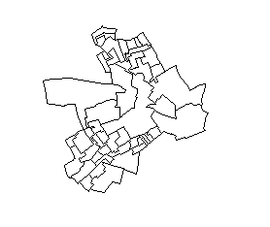

> unique(my.shp$ED91)

[1] 08CXGD01 08CXGD02 08CXGD11 08CXGD03 08CXGD10 08CXGD04 08CXGD09 08CXGD08

[9] 08CXGD12 08CXGD14 08CXGD07 08CXGD13 08CXGD05 08CXGD06 08CXGD17 08CXGD16

[17] 08CXGD15 08CXGD18 08CXGD20 08CXGD19 08CXGD21 08CXGD23 08CXGD22 08CXGD41

[25] 08CXGD24 08CXGD25 08CXGD40 08CXGD32 08CXGD27 08CXGD30 08CXGD31 08CXGD26

[33] 08CXGD39 08CXGD29 08CXGD38 08CXGD36 08CXGD35 08CXGD28 08CXGD37 08CXGD34

[41] 08CXGD42 08CXGD33 08CXGD43 08CXGD50 08CXGD45 08CXGD46 08CXGD44 08CXGD47

[49] 08CXGD49 08CXGD48

50 Levels: 08CXGD01 08CXGD02 08CXGD03 08CXGD04 08CXGD05 08CXGD06 ... 08CXGD50

> unique(my.data$ed91)

[1] 08CXGD01 08CXGD02 08CXGD03 08CXGD04 08CXGD05 08CXGD06 08CXGD07 08CXGD08

[9] 08CXGD09 08CXGD10 08CXGD11 08CXGD12 08CXGD13 08CXGD14 08CXGD15 08CXGD16

[17] 08CXGD17 08CXGD18 08CXGD19 08CXGD20 08CXGD21 08CXGD22 08CXGD23 08CXGD24

[25] 08CXGD25 08CXGD26 08CXGD27 08CXGD28 08CXGD29 08CXGD30 08CXGD31 08CXGD32

[33] 08CXGD33 08CXGD34 08CXGD35 08CXGD36 08CXGD37 08CXGD38 08CXGD39 08CXGD40

[41] 08CXGD41 08CXGD42 08CXGD43 08CXGD44 08CXGD45 08CXGD46 08CXGD47 08CXGD48

[49] 08CXGD49 08CXGD50

50 Levels: 08CXGD01 08CXGD02 08CXGD03 08CXGD04 08CXGD05 08CXGD06 ... 08CXGD50

> my.shp@data = data.frame(my.shp@data,

+ my.data[match(my.shp@data$ED91, my.data$ed91),])

> head(data.frame(my.shp))

AREA PERIMETER ED91 ed91 Easting Northing area allppl VoteIndex

0 51983.5 1481.204 08CXGD01 08CXGD01 414688 434459 51983.5 464 106.49

1 23364.0 1029.482 08CXGD02 08CXGD02 414874 434450 23364.0 334 85.10

2 31558.0 766.436 08CXGD11 08CXGD11 415576 434387 31558.0 162 54.54

3 21365.0 610.590 08CXGD03 08CXGD03 414788 434351 21365.0 473 123.30

4 13923.0 554.163 08CXGD10 08CXGD10 415474 434348 13923.0 236 90.11

5 93963.5 1819.617 08CXGD04 08CXGD04 414906 434204 93963.5 371 106.22

wht_oth_pc ipb_pc non_home_own_pc no_car_pc overcr_pc loneparent_pc unemp_pc

0 30.47 65.24 45.52 51.13 8.27 1.42 11.72

1 42.73 55.19 58.82 80.00 9.70 3.90 15.42

2 77.64 18.63 89.89 82.02 3.37 2.11 24.09

3 8.67 91.12 12.26 64.15 9.52 1.71 13.81

4 34.45 61.76 79.12 80.90 2.25 8.25 18.92

5 20.75 75.74 64.60 77.48 6.31 1.65 14.50

single_pens_pc single_pers_pc ft_pc stud_pc hh_llti_pc Multi_stress

0 21.21 10.61 23.81 5.86 10.78 One stress indicator

1 26.67 20.00 23.35 3.08 17.96 Three stress indicators

2 15.38 62.64 21.90 5.11 17.28 Three stress indicators

3 5.61 8.41 20.90 4.85 12.47 Four stress indicators

4 13.64 43.18 16.89 6.08 18.22 Four stress indicators

5 32.73 11.82 15.50 7.00 19.41 Four stress indicators

multistress

0 None or little stress

1 Multiple stress

2 Multiple stress

3 Multiple stress

4 Multiple stress

5 Multiple stress

|  |
| --- |
| > choropleth(my.shp, my.shp$VoteIndex) |
|  |
| |  | | --- | | > | |

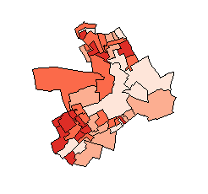

|  |
| --- |
| > choropleth(my.shp, my.shp$VoteIndex)  > shades = auto.shading(my.shp$VoteIndex,  + cutter = rangeCuts, cols= brewer.pal(6,'YlOrRd'))  > choropleth(my.shp, my.shp$VoteIndex, shades) |
|  |
| |  | | --- | | > | |

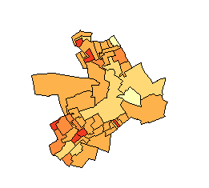

> display.brewer.all()

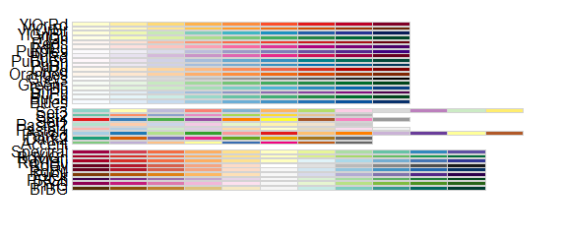

|  |
| --- |
| > my.cols <- rep("white", length(my.shp$VoteIndex))  > index <- my.shp$VoteIndex > 105  > my.cols[index] <- "red"  > index <- my.shp$VoteIndex < 95  > my.cols[index] <- "blue"  > plot(my.shp, col = my.cols) |
|  |
| |  | | --- | |  | |

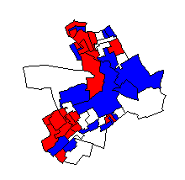

|  |
| --- |
| > grep("_pc", names(my.data))  [1] 7 8 9 10 11 12 13 14 15 16 17 18  > boxplot(my.data$VoteIndex, col = "gold") |
|  |
| |  | | --- | | > | |

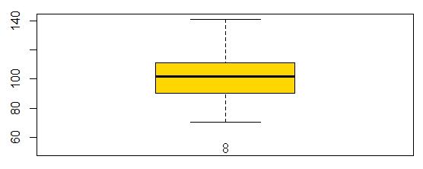

|  |
| --- |
| > boxplot(my.data[,grep("_pc", names(my.data))],  + col = "gold", cex = 0.5,  + ylim = c(0, 100), las = 2) |
|  |
| |  | | --- | | > | |

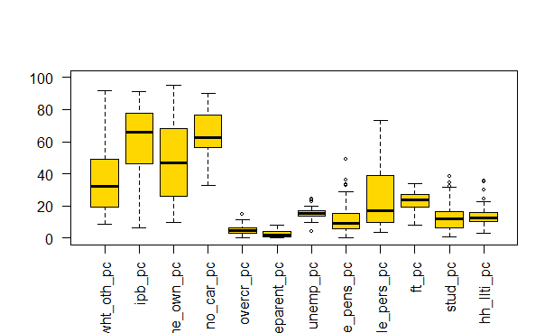

|  |
| --- |
| > table(my.shp$multistress)  None or little stress Multiple stress  15 35  > table(my.shp$multistress) / sum(table(my.shp$multistress))  None or little stress Multiple stress  0.3 0.7  > t(rbind(table(my.shp$multistress),  + table(my.shp$multistress) / sum(table(my.shp$multistress))))  [,1] [,2]  None or little stress 15 0.3  Multiple stress 35 0.7  > cor(my.data$ipb_pc, my.data$VoteIndex,  + method = "pearson")  [1] 0.6905985  > cor.test(my.data$ipb_pc, my.data$VoteIndex,  + method = "pearson")  Pearson's product-moment correlation  data: my.data$ipb_pc and my.data$VoteIndex  t = 6.6155, df = 48, p-value = 2.859e-08  alternative hypothesis: true correlation is not equal to 0  95 percent confidence interval:  0.5103544 0.8127199  sample estimates:  cor  0.6905985  > plot(my.data$ipb_pc, my.data$VoteIndex) |
|  |
| |  | | --- | | > | |

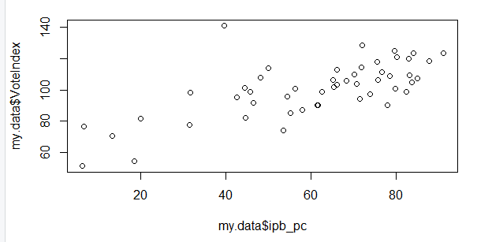

|  |
| --- |
| > plot(my.data$ipb_pc, my.data$VoteIndex)  > cor.test(as.numeric(my.data$multistress)-1,  + my.data$VoteIndex,method = "spearman")  Spearman's rank correlation rho  data: as.numeric(my.data$multistress) - 1 and my.data$VoteIndex  S = 26336, p-value = 0.06329  alternative hypothesis: true rho is not equal to 0  sample estimates:  rho  -0.2646281  Warning message:  In cor.test.default(as.numeric(my.data$multistress) - 1, my.data$VoteIndex, :  Cannot compute exact p-value with ties |
|  |
| |  | | --- | | > | |
| > plot(as.numeric(my.data$multistress)-1,  + my.data$VoteIndex, xlab = "multistress") |
|  |
| |  | | --- | | > | |

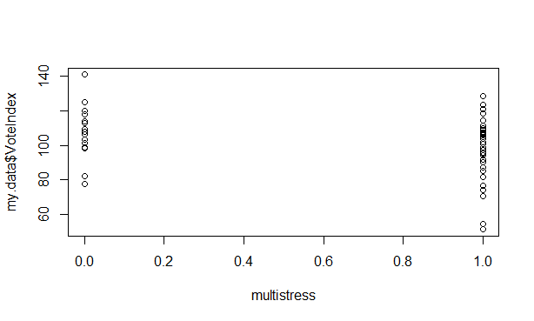

|  |
| --- |
| > model.1 <- lm(my.data$VoteIndex~my.data$ipb_pc)  > summary(model.1)  Call:  lm(formula = my.data$VoteIndex ~ my.data$ipb_pc)  Residuals:  Min 1Q Median 3Q Max  -22.781 -9.339 -0.746 6.677 51.739  Coefficients:  Estimate Std. Error t value Pr(>|t|)  (Intercept) 66.93961 5.40691 12.380 < 2e-16 ***  my.data$ipb_pc 0.55725 0.08423 6.616 2.86e-08 ***  ---  Signif. codes: 0 ‘***’ 0.001 ‘**’ 0.01 ‘*’ 0.05 ‘.’ 0.1 ‘ ’ 1  Residual standard error: 12.91 on 48 degrees of freedom  Multiple R-squared: 0.4769, Adjusted R-squared: 0.466  F-statistic: 43.77 on 1 and 48 DF, p-value: 2.859e-08  > attach(my.data)  > model.1 <- lm(VoteIndex~ipb_pc)  > new.data = data.frame(ipb_pc = c(10,30,75))  > predict(model.1, new.data, interval = "predict")  fit lwr upr  1 72.51206 44.93704 100.0871  2 83.65697 56.93604 110.3779  3 108.73302 82.39737 135.0687  > detach(my.data)  > ls()  [1] "index" "model.1" "my.cols" "my.data" "my.shp" "new.data" "shades"  > save.image(file = "Prac2.RData")  > save(list = c("my.shp", "my.data"), file = "my.shp.data.RData")  > writePolyShape(my.shp, "my_shp.shp")  Warning message:  use rgdal::readOGR or sf::st_read |
|  |
| |  | | --- | | > | |